OHAYO PIZZAS
2015 Sales Analysis Report

Prepared using order, order-detail, pizza, and pizza-type transaction data

1. Introduction
Ohayo Pizzas is a pizza restaurant business that captures every customer order through a relational database spanning four linked tables: orders, order details, pizzas, and pizza types. Over the course of 2015, the business processed 21,350 orders comprising 48,620 order line items, selling a total of 49,574 pizzas across 32 unique pizza varieties spread over 4 categories — Classic, Chicken, Supreme, and Veggie.
This report uses that transactional data to understand how the business performed across the year and where its revenue is really coming from, providing a foundation for menu, staffing, and promotional decisions.

2. Objective
The objective of this sales analysis is to evaluate Ohayo Pizzas' performance over 2015 in order to:
- Determine total revenue, order volume, and average order value
- Identify best- and worst-performing pizzas by revenue and quantity sold
- Understand which categories and sizes drive the most sales
- Detect seasonal, monthly, and day-of-week ordering patterns
- Provide data-backed recommendations to support menu, staffing, and promotional decisions

3. Dataset Description
The dataset consists of four related CSV tables, joined via order_id, pizza_id, and pizza_type_id to build a complete transactional view of every sale. Each table is described individually below.

3.1 orders.csv (21,350 rows)
Stores one record per customer order, capturing when each order was placed.
Field | Description
order_id | Unique identifier for each customer order (primary key)
date | Calendar date the order was placed (YYYY-MM-DD)
time | Time of day the order was placed (HH:MM:SS)

3.2 order_details.csv (48,620 rows)
Stores the individual line items within each order — i.e. which pizzas, and how many, were part of a given order. This is the table that links orders to the pizzas purchased.
Field | Description
order_details_id | Unique identifier for each order line item (primary key)
order_id | Identifier linking this line item back to its parent order (foreign key → orders.csv)
pizza_id | Identifier of the specific pizza variant ordered (foreign key → pizzas.csv)
quantity | Number of units of that pizza variant purchased in this line item

3.3 pizzas.csv (96 rows)
Stores each purchasable pizza variant — a combination of a pizza type and a size — along with its price.
Field | Description
pizza_id | Unique identifier for a specific pizza variant, e.g. size and type combined (primary key)
pizza_type_id | Identifier linking this variant to its pizza type (foreign key → pizza_types.csv)
size | Size of the pizza — Small (S), Medium (M), Large (L), X-Large (XL), or XX-Large (XXL)
price | Selling price of the pizza at this size, in dollars

3.4 pizza_types.csv (32 rows)
Stores descriptive information about each distinct pizza recipe, independent of size or price.
Field | Description
pizza_type_id | Unique identifier for each pizza recipe/type (primary key)
name | Display name of the pizza, e.g. "The Barbecue Chicken Pizza"
category | Menu category the pizza belongs to — Classic, Chicken, Supreme, or Veggie
ingredients | Comma-separated list of ingredients used in the pizza

The data spans the full 2015 calendar year (January 1 – December 31), giving a complete view of a single year of trading.

4. Analysis & Key Findings

4.1 Overall Performance
Metric | Value
Total Revenue | $817,860.05
Total Orders | 21,350
Total Pizzas Sold | 49,574
Average Order Value | $38.31

4.2 Revenue by Category
Classic pizzas generated the most category revenue ($220,053), narrowly ahead of Supreme ($208,197), Chicken ($195,920), and Veggie ($193,690). The spread across categories is fairly balanced, but Classic and Supreme together account for just over half of total sales.4.3 Revenue by Size
Large (L) pizzas dominate, contributing $375,319 — about 46% of total revenue — more than Medium and Small combined. This suggests customers consistently choose to upsize, making Large the anchor size for the menu.

4.4 Monthly Revenue Trend
Revenue is fairly stable across the year with no extreme seasonality. July was the strongest month ($72,558), while September and October were the weakest (around $64,000 each).

4.5 Revenue by Day of Week
Friday ($136,074) and Thursday ($123,529) are the busiest days, while Sunday is the slowest ($99,204) — a clear weekly demand pattern that is useful for staffing and inventory planning.

4.6 Top-Performing Pizzas
The Thai Chicken Pizza is the single highest revenue earner ($43,434), followed closely by The Barbecue Chicken Pizza ($42,768) and The California Chicken Pizza ($41,410). By volume, The Classic Deluxe Pizza sells the most units (2,453), narrowly ahead of The Barbecue Chicken Pizza (2,432) and The Hawaiian Pizza (2,422) — indicating that premium/specialty pizzas earn more per unit even at comparable or slightly lower volumes.

5. Insights
- retrieve the total number of orders placed

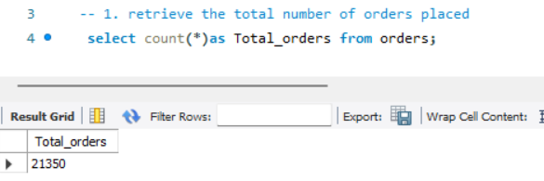

- Calculate the total revenue generated from pizza sales
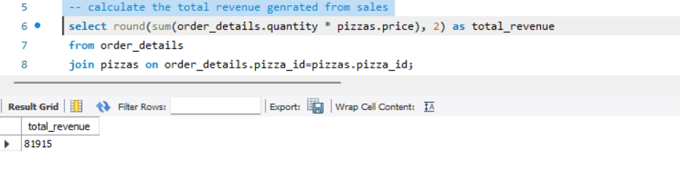

- the highest-priced pizza.
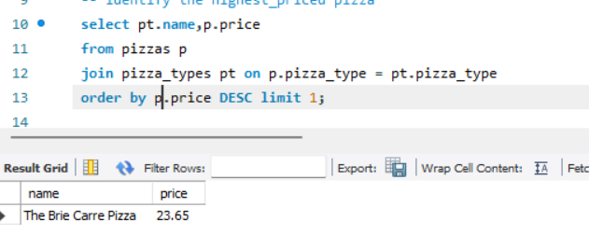
- Identify the most common pizza size ordered.
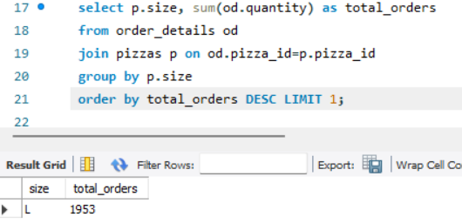

- List the top 5 most ordered pizza types along with their quantities.
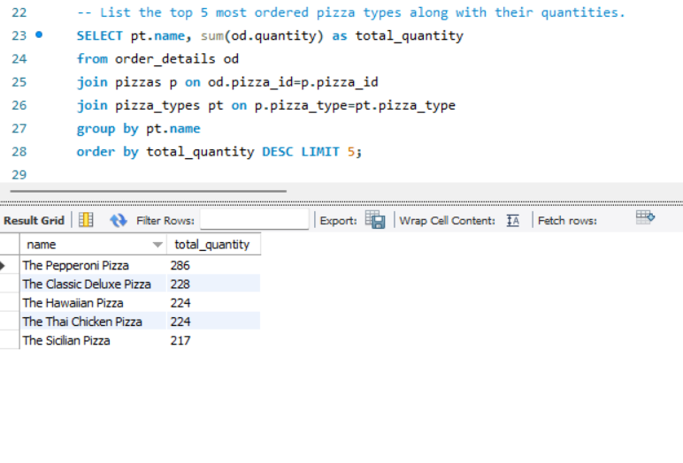
- Join the necessary tables to find the total quantity of each pizza category ordered.
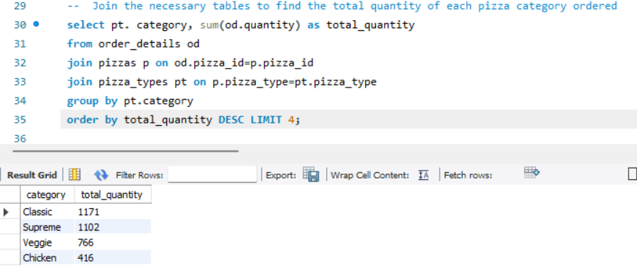
- Determine the distribution of orders by hour of the day.
- Join relevant tables to find the category-wise distribution of pizzas.
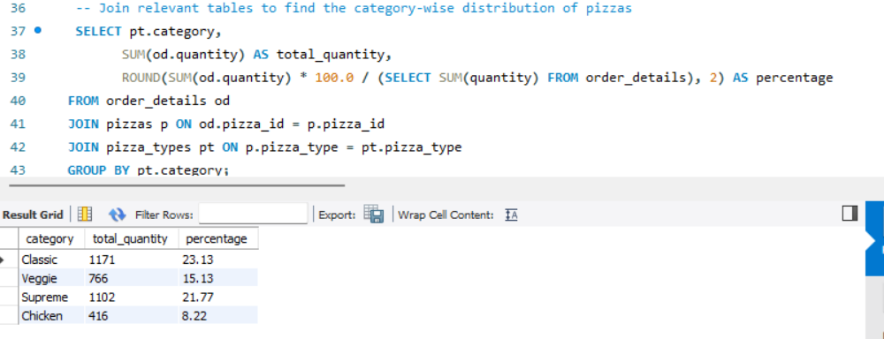
- Group the orders by date and calculate the average number of pizzas ordered per day.
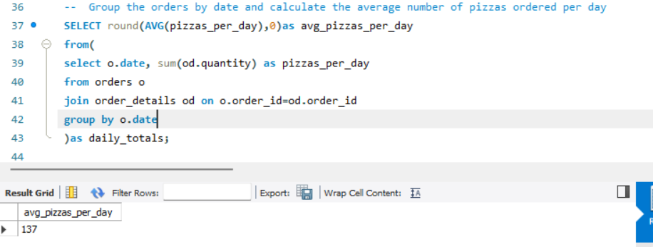
- Determine the top 3 most ordered pizza types based on revenue.
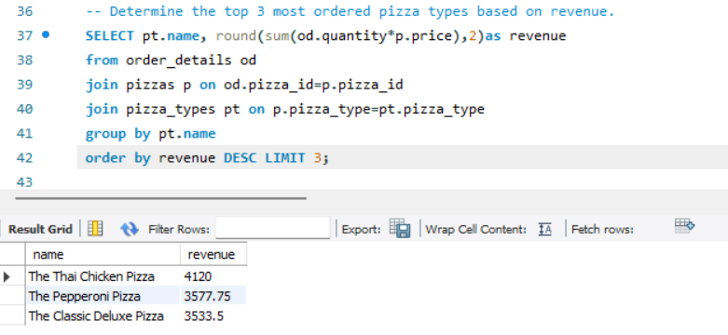

6. Conclusion
- Ohayo Pizzas generated $817,860.05 in total revenue from 21,350 orders in 2015, at an average order value of $38.31.
- Classic and Supreme pizzas are the top revenue categories, though all four categories are closely matched.
- Large-size pizzas are the clear revenue driver, contributing nearly half of all sales.
- Chicken-category specialty pizzas (Thai Chicken, Barbecue Chicken, California Chicken) punch above their weight, generating outsized revenue relative to volume.
- Demand peaks on Thursday through Saturday and dips on Sunday, a pattern that should inform staffing and inventory decisions.
- Monthly revenue is stable year-round with no strong seasonal swings, aside from a modest summer (July) peak and a autumn (Sep–Oct) dip.

Recommendation: Ohayo Pizzas should focus promotions on driving further Large-size upgrades, protect and market its top Chicken-category pizzas which deliver strong revenue per unit, and align staffing and inventory more heavily toward Thursday–Saturday demand.

